**PIZZA SALES REPORT**

**Problem Statement**

**KPI'S REQUIREMENT**

**We need to analyze key indicators for our pizza sales data to gain insights into our business performance. Specifically, we want to calculate the following metrics:**

**1. Total Revenue: The sum of the total price of all pizza orders.**

**2. Average Order Value: The average amount spent per order, calculated by dividing the total revenue by the total number of orders.**

**3. Total Pizzas Sold: The sum of the quantities of all pizzas sold.**

**4. Total Orders: The total number of orders placed.**

**5. Average Pizzas Per Order: The average number of pizzas sold per order, calculated by dividing the total number of pizzas sold by the total number of orders.**

**CHARTS REQUIREMENT**

**We would like to visualize various aspects of our pizza sales data to gain insights and understand key trends. We have identified the following requirements for creating charts:**

**1.Daily Trend for Total Orders:**

**Create a bar chart that displays the daily trend of total orders over a specific time period. This chart will help us identify any patterns or fluctuations in order volumes on a daily basis.**

**2.Monthly Trend for Total Orders:**

**Create a line chart that illustrates the hourly trend of total orders throughout the day. This chart will allow us to identify peak hours or periods of high order activity.**

**3.Percentage of Sales by Pizza Category:**

**Create a pie chart that shows the distribution of sales across different pizza categories. This chart will provide insights into the popularity of various pizza categories and their contribution to overall sales.**

**4.Percentage of Sales by Pizza Size:**

**Generate a pie chart that represents the percentage of sales attributed to different pizza sizes. This chart will help us understand customer preferences for pizza sizes and their impact on sales.**

**5.Total Pizzas Sold by Pizza Category:**

**Create a funnel chart that presents the total number of pizzas sold for each pizza category. This chart will allow us to compare the sales performance of different pizza categories.**

**6.Top 5 Best Sellers by Revenue, Total Quantity and Total Orders**

**Create a bar chart highlighting the top 5 best-selling pizzas based on the Revenue, Total Quantity, Total Orders. This chart will help us identify the most popular pizza options.**

**7. Bottom 5 Best Sellers by Revenue, Total Quantity and Total Orders**

**Create a bar chart showcasing the bottom 5 worst-selling pizzas based on the Revenue, Total Quantity. Total Orders. This chart will enable us to identify underperforming or less popular pizza options.**

**PIZZA SALES SQL QUERIES**

**A. KPI’s**

**1. Total Revenue:**

SELECT SUM(total_price) AS Total_Revenue FROM pizza_sales;

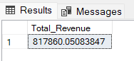

**2. Average Order Value**

SELECT (SUM(total_price) / COUNT(DISTINCT order_id)) AS Avg_order_Value FROM pizza_sales

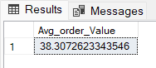

**3. Total Pizzas Sold**

SELECT SUM(quantity) AS Total_pizza_sold FROM pizza_sales

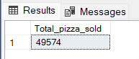

**4. Total Orders**

SELECT COUNT(DISTINCT order_id) AS Total_Orders FROM pizza_sales

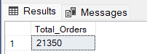

**5. Average Pizzas Per Order**

SELECT CAST(CAST(SUM(quantity) AS DECIMAL(10,2)) /

CAST(COUNT(DISTINCT order_id) AS DECIMAL(10,2)) AS DECIMAL(10,2))

AS Avg_Pizzas_per_order

FROM pizza_sales

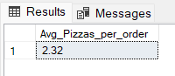

**B. Daily Trend for Total Orders**SELECT DATENAME(DW, order_date) AS order_day, COUNT(DISTINCT order_id) AS total_orders

FROM pizza_sales

GROUP BY DATENAME(DW, order_date)

***Output:***

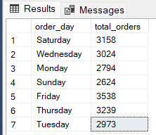

**C. Monthly Trend for Orders**

select DATENAME(MONTH, order_date) as Month_Name, COUNT(DISTINCT order_id) as Total_Orders

from pizza_sales

GROUP BY DATENAME(MONTH, order_date)

***Output***

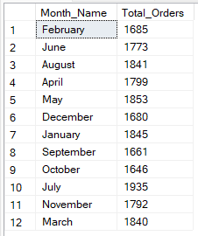

**D. % of Sales by Pizza Category**

SELECT pizza_category, CAST(SUM(total_price) AS DECIMAL(10,2)) as total_revenue,

CAST(SUM(total_price) * 100 / (SELECT SUM(total_price) from pizza_sales) AS DECIMAL(10,2)) AS PCT

FROM pizza_sales

GROUP BY pizza_category

***Output***

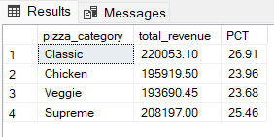

**E. % of Sales by Pizza Size**

SELECT pizza_size, CAST(SUM(total_price) AS DECIMAL(10,2)) as total_revenue,

CAST(SUM(total_price) * 100 / (SELECT SUM(total_price) from pizza_sales) AS DECIMAL(10,2)) AS PCT

FROM pizza_sales

GROUP BY pizza_size

ORDER BY pizza_size

***Output***

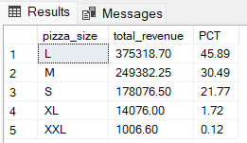

**F. Total Pizzas Sold by Pizza Category**

SELECT pizza_category, SUM(quantity) as Total_Quantity_Sold

FROM pizza_sales

WHERE MONTH(order_date) = 2

GROUP BY pizza_category

ORDER BY Total_Quantity_Sold DESC

***Output***

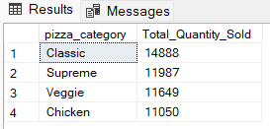

**G. Top 5 Pizzas by Revenue**

SELECT Top 5 pizza_name, SUM(total_price) AS Total_Revenue

FROM pizza_sales

GROUP BY pizza_name

ORDER BY Total_Revenue DESC

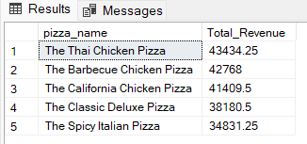

**H. Bottom 5 Pizzas by Revenue**

SELECT Top 5 pizza_name, SUM(total_price) AS Total_Revenue

FROM pizza_sales

GROUP BY pizza_name

ORDER BY Total_Revenue ASC

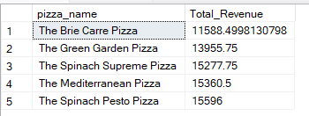

**I. Top 5 Pizzas by Quantity**

SELECT Top 5 pizza_name, SUM(quantity) AS Total_Pizza_Sold

FROM pizza_sales

GROUP BY pizza_name

ORDER BY Total_Pizza_Sold DESC

***Output***

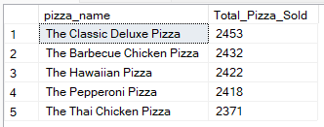

**J. Bottom 5 Pizzas by Quantity**

SELECT TOP 5 pizza_name, SUM(quantity) AS Total_Pizza_Sold

FROM pizza_sales

GROUP BY pizza_name

ORDER BY Total_Pizza_Sold ASC

***Output***

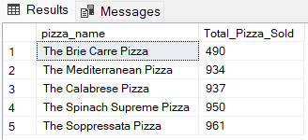

**K. Top 5 Pizzas by Total Orders**

SELECT Top 5 pizza_name, COUNT(DISTINCT order_id) AS Total_Orders

FROM pizza_sales

GROUP BY pizza_name

ORDER BY Total_Orders DESC

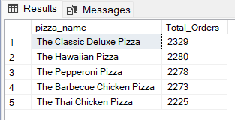

**L. Borrom 5 Pizzas by Total Orders**

SELECT Top 5 pizza_name, COUNT(DISTINCT order_id) AS Total_Orders

FROM pizza_sales

GROUP BY pizza_name

ORDER BY Total_Orders ASC

